Day 23 - 2nd August- 113195064 - Bondili Bhavya Charitha

TASK:1 –
import org.junit.jupiter.api.Test;
import org.junit.jupiter.api.Tag;

public class TestCase2 {

@Test
@Tag("firstPriority")
void testMethod01() {
System.out.println("testMethod01 - Tag: firstPriority");
}

@Test
@Tag("firstPriority")
void runTestcase02() {
System.out.println("runTestcase02 - Tag: firstPriority");
}

@Test
@Tag("fastTag")
void testMethod03() {
System.out.println("testMethod03 - Tag: fastTag");
}

@Test
@Tag("slowTag")
void runTestcase04() {
System.out.println(“runTestcase04 - Tag: slowTag (should be excluded)");
}
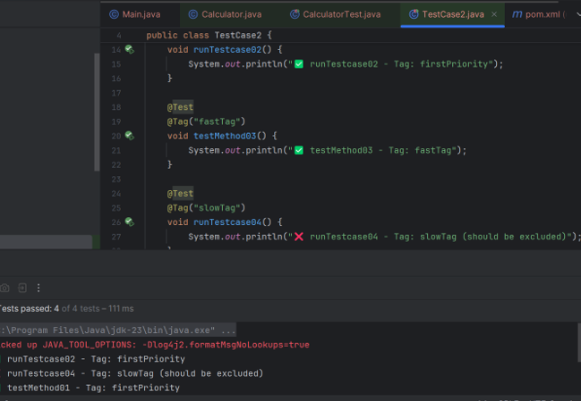

TASK:2 -
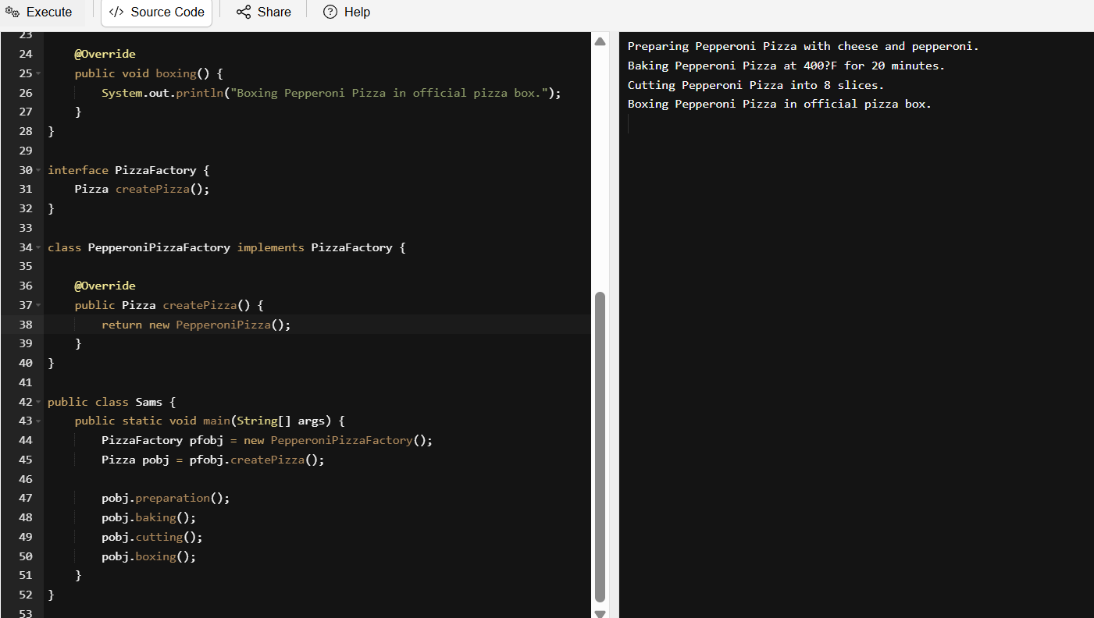
interface Pizza {
void preparation();
void baking();
void cutting();
void boxing();
}
class PepperoniPizza implements Pizza {

@Override
public void preparation() {
System.out.println("Preparing Pepperoni Pizza with cheese and pepperoni.");
}

@Override
public void baking() {
System.out.println("Baking Pepperoni Pizza at 400°F for 20 minutes.");
}

@Override
public void cutting() {
System.out.println("Cutting Pepperoni Pizza into 8 slices.");
}

@Override
public void boxing() {
System.out.println("Boxing Pepperoni Pizza in official pizza box.");
}
}

interface PizzaFactory {
Pizza createPizza();
}

class PepperoniPizzaFactory implements PizzaFactory {

@Override
public Pizza createPizza() {
return new PepperoniPizza();
}
}

public class Sams {
public static void main(String[] args) {
PizzaFactory pfobj = new PepperoniPizzaFactory();
Pizza pobj = pfobj.createPizza();

pobj.preparation();
pobj.baking();
pobj.cutting();
pobj.boxing();
}
}

TASK:3 –
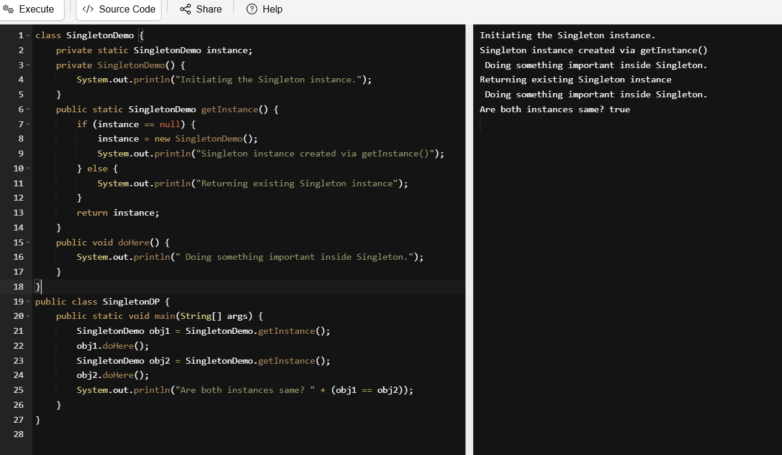
class SingletonDemo {
private static SingletonDemo instance;
private SingletonDemo() {
System.out.println("Initiating the Singleton instance.");
}
public static SingletonDemo getInstance() {
if (instance == null) {
instance = new SingletonDemo();
System.out.println("Singleton instance created via getInstance()");
} else {
System.out.println("Returning existing Singleton instance");
}
return instance;
}
public void doHere() {
System.out.println(" Doing something important inside Singleton.");
}
}
public class SingletonDP {
public static void main(String[] args) {
SingletonDemo obj1 = SingletonDemo.getInstance();
obj1.doHere();
SingletonDemo obj2 = SingletonDemo.getInstance();
obj2.doHere();
System.out.println("Are both instances same? " + (obj1 == obj2));
}
}

Home Task: 1
Write a test case for the below java file
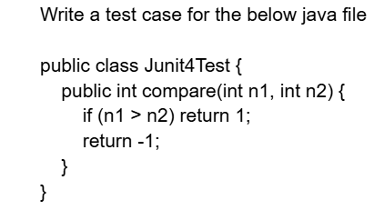
import static org.junit.Assert.assertEquals;
import org.junit.Before;
import org.junit.Test;

public class Junit4TestTest {

private Junit4Test junit4Test;

@Before
public void setUp() {
junit4Test = new Junit4Test();
}

@Test
public void testCompareGreater() {
int result = junit4Test.compare(10, 5);
assertEquals(1, result);
}

@Test
public void testCompareSmaller() {
int result = junit4Test.compare(3, 8);
assertEquals(-1, result);
}

@Test
public void testCompareEqual() {
int result = junit4Test.compare(7, 7);
assertEquals(-1, result); // Based on your logic, equal values return -1
}
}

Home Task: 2
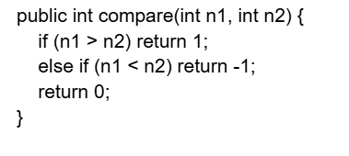
import static org.junit.Assert.assertEquals;
import org.junit.Before;
import org.junit.Test;

public class CompareTest {

private Junit4Test junit4Test;

@Before
public void setUp() {
junit4Test = new Junit4Test();
}

@Test
public void testCompareGreater() {
assertEquals(1, junit4Test.compare(10, 5));
}

@Test
public void testCompareSmaller() {
assertEquals(-1, junit4Test.compare(3, 8));
}

@Test
public void testCompareEqual() {
assertEquals(0, junit4Test.compare(7, 7));
}
}

Home Task:3 - Include a test case and run the test suite.
public class MessageUtil {
private String message;

public MessageUtil(String message) {
this.message = message;
}

public String printMessage() {
return message;
}
}
import org.junit.Test;
import static org.junit.Assert.assertEquals;

public class JunitTest01 {

String msg = "running test01 ";
MessageUtil msgUtilobj = new MessageUtil(msg);

@Test
public void msgTest() {
System.out.println("we are inside the msgTest()");
assertEquals(msg, msgUtilobj.printMessage());
}
}
import org.junit.Test;
import static org.junit.Assert.assertEquals;

public class JunitTest02 {

String msg = "running test02 ";
MessageUtil msgUtilobj = new MessageUtil(msg);

@Test
public void msgTest() {
System.out.println("we are inside the msgTest() of test02");
assertEquals(msg, msgUtilobj.printMessage());
}
}
import org.junit.Test;
import static org.junit.Assert.assertEquals;

public class JunitTest03 {

@Test
public void compareTest() {
Junit4Test obj = new Junit4Test();
assertEquals(0, obj.compare(5, 5));
assertEquals(1, obj.compare(10, 5));
assertEquals(-1, obj.compare(3, 8));
}
}
public class Junit4Test {
public int compare(int n1, int n2) {
if (n1 > n2) return 1;
else if (n1 < n2) return -1;
return 0;
}
}
import org.junit.runner.RunWith;
import org.junit.runners.Suite;

@RunWith(Suite.class)
@Suite.SuiteClasses({
JunitTest01.class,
JunitTest02.class,
JunitTest03.class
})
public class TestSuiteDemo {
// No code needed here. This class runs all tests together.
}

Home Task: 4 – Implement the above code also add one more test case and test runner.. And execute the test suite.
import org.junit.Test;
import org.junit.runner.RunWith;
import org.junit.runners.Suite;
import org.junit.runner.JUnitCore;
import org.junit.runner.Result;
import org.junit.runner.notification.Failure;
import static org.junit.Assert.assertEquals;

// Utility class
class MessageUtil {
private String message;

public MessageUtil(String message) {
this.message = message;
}

public String printMessage() {
return message;
}
}

// Business logic class
class Junit4Test {
public int compare(int n1, int n2) {
if (n1 > n2) return 1;
else if (n1 < n2) return -1;
return 0;
}
}

// Test Case 1
class JunitTest01 {
String msg = "running test01 ";
MessageUtil msgUtilobj = new MessageUtil(msg);

@Test
public void msgTest() {
System.out.println("Inside JunitTest01.msgTest()");
assertEquals(msg, msgUtilobj.printMessage());
}
}

// Test Case 2
class JunitTest02 {
String msg = "running test02 ";
MessageUtil msgUtilobj = new MessageUtil(msg);

@Test
public void msgTest() {
System.out.println("Inside JunitTest02.msgTest()");
assertEquals(msg, msgUtilobj.printMessage());
}
}

// Test Case 3
class JunitTest03 {
Junit4Test compareUtil = new Junit4Test();

@Test
public void compareEqualTest() {
System.out.println("Inside JunitTest03.compareEqualTest()");
assertEquals(0, compareUtil.compare(5, 5));
}

@Test
public void compareGreaterTest() {
System.out.println("Inside JunitTest03.compareGreaterTest()");
assertEquals(1, compareUtil.compare(10, 5));
}

@Test
public void compareSmallerTest() {
System.out.println("Inside JunitTest03.compareSmallerTest()");
assertEquals(-1, compareUtil.compare(3, 8));
}
}

// Test Case 4 (New Added)
class JunitTest04 {
@Test
public void customMessageTest() {
System.out.println("Inside JunitTest04.customMessageTest()");
MessageUtil util = new MessageUtil("Hello JUnit!");
assertEquals("Hello JUnit!", util.printMessage());
}
}

// Test Suite
@RunWith(Suite.class)
@Suite.SuiteClasses({
JunitTest01.class,
JunitTest02.class,
JunitTest03.class,
JunitTest04.class
})
class TestSuiteDemo {
// Empty class to hold annotations
}

// Test Runner
public class IntegratedTestRunner {
public static void main(String[] args) {
Result result = JUnitCore.runClasses(TestSuiteDemo.class);

for (Failure failure : result.getFailures()) {
System.out.println("Test failed: " + failure.toString());
}

System.out.println("All tests successful: " + result.wasSuccessful());
}
}

Home Task: 5 – Tried code in UML
Here is the output for the given code.
